Chapter-8
8.1 OUTPUT SCREENS
HOME PAGE :
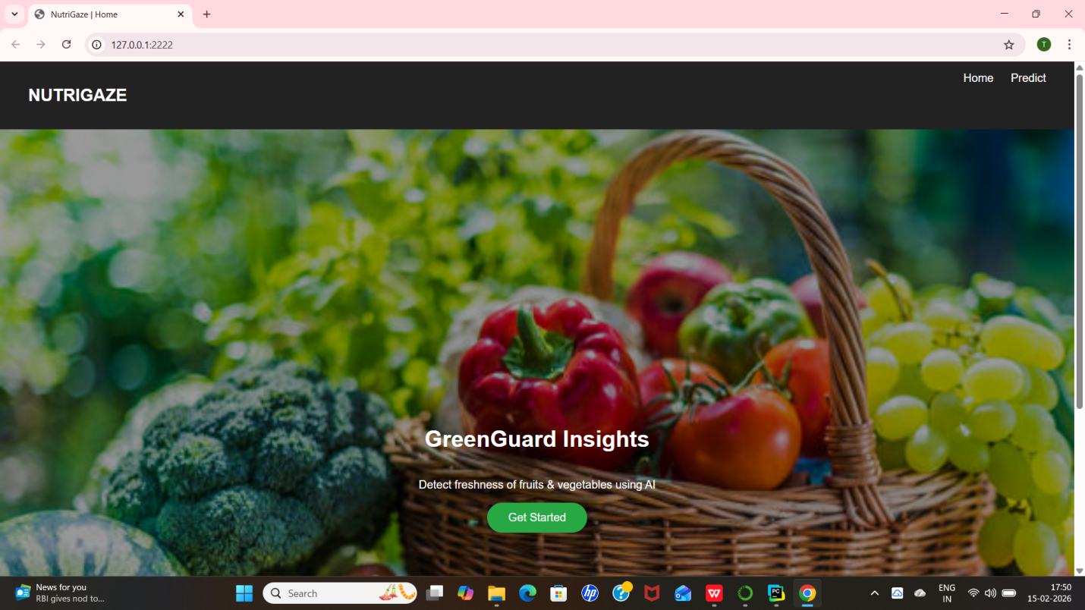
PREDICT PAGE :
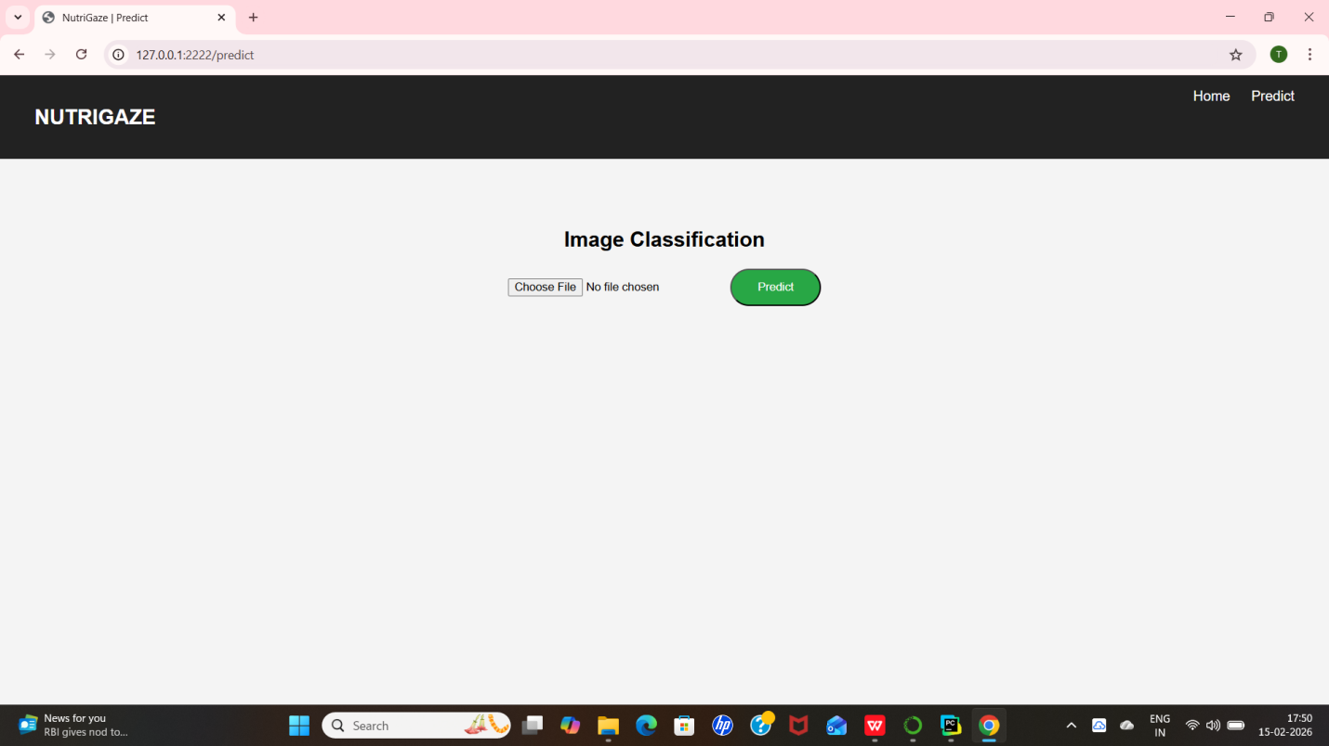
CHOOSING AN IMAGE:
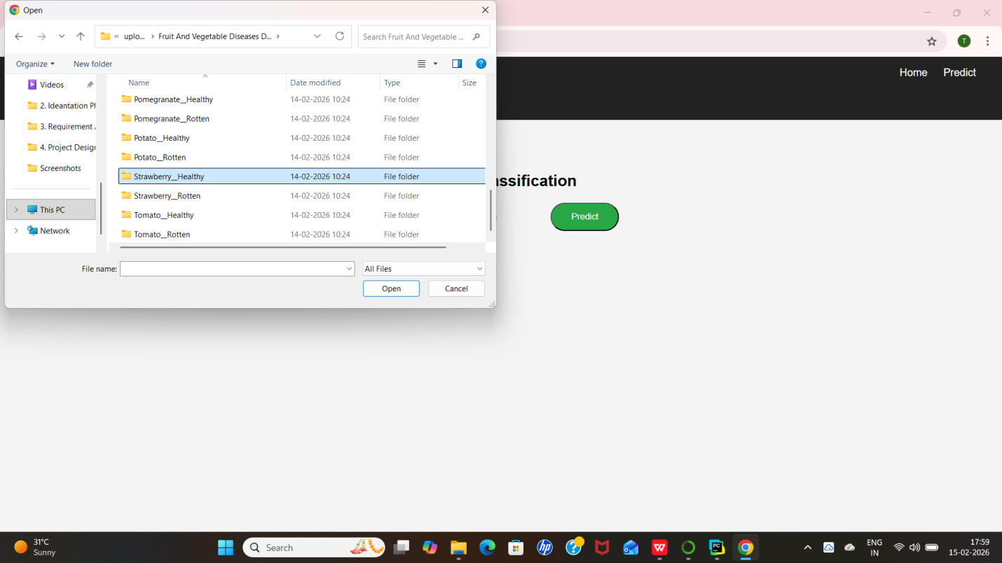
OUTPUT:
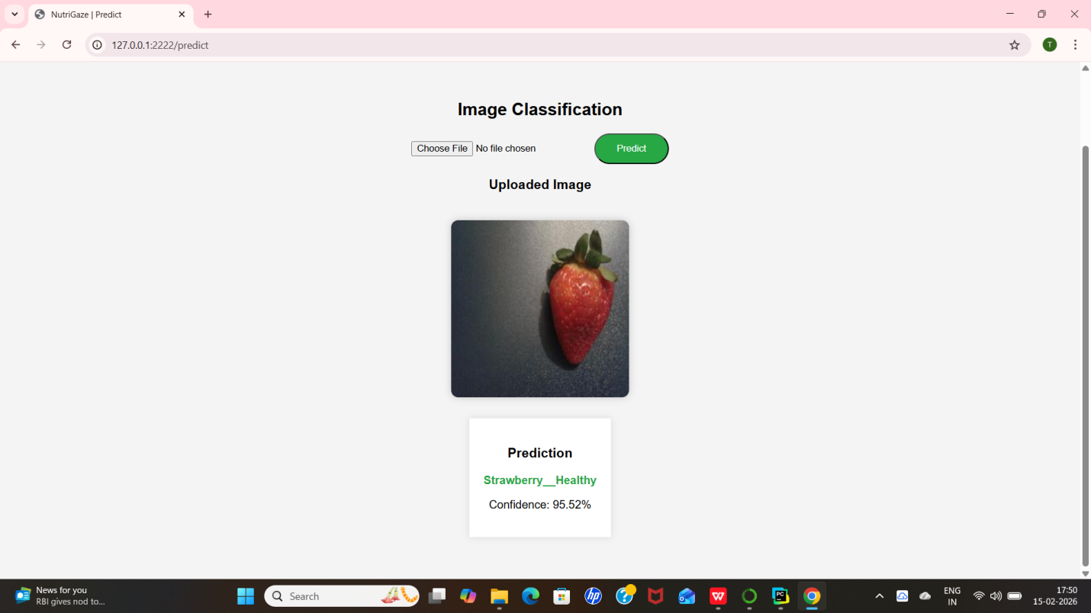

TESTING ANOTHER IMAGE FROM DATASET:
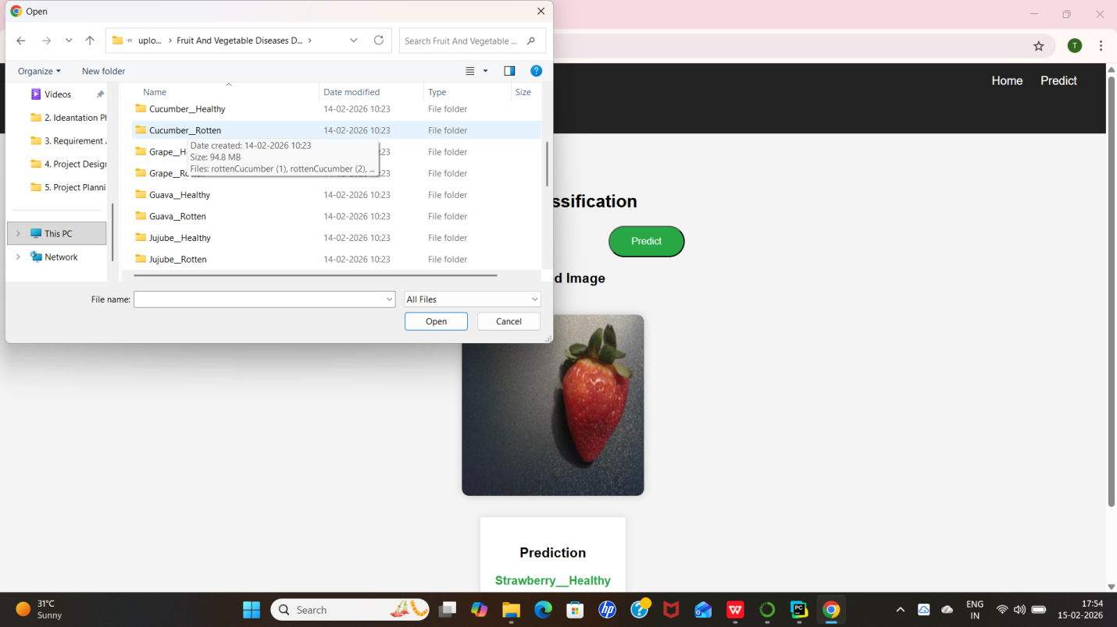
SELECTING ROTTEN CUCUMBER :
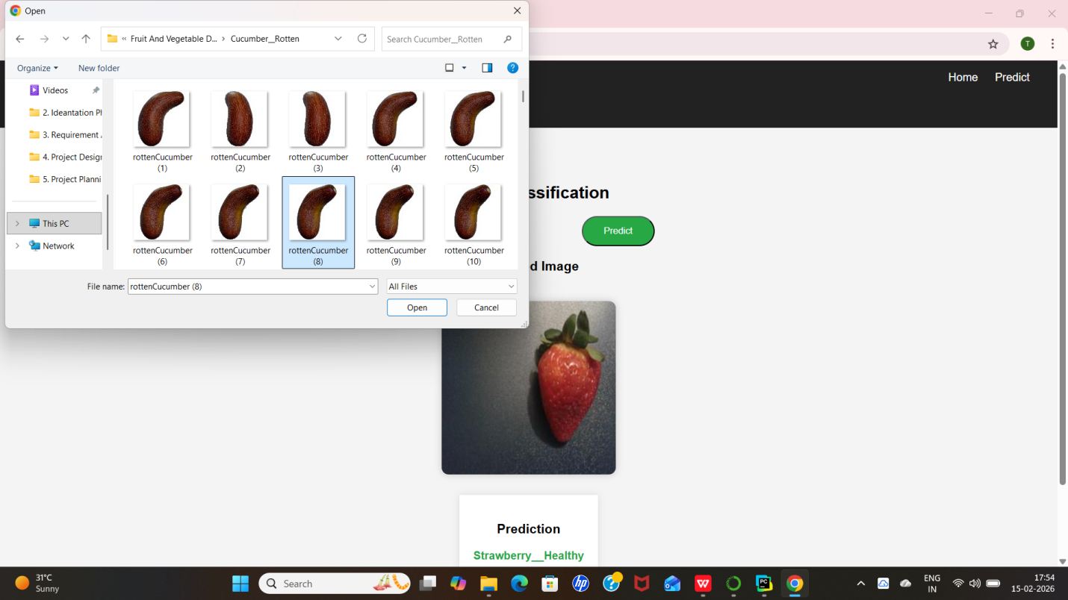

OUTPUT:
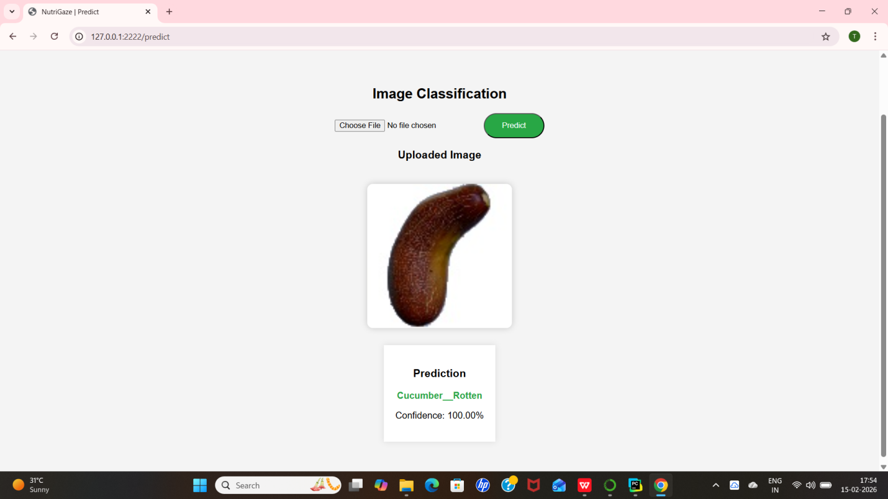
TESTING THE MODEL WITH UNKNOWN IMAGES:
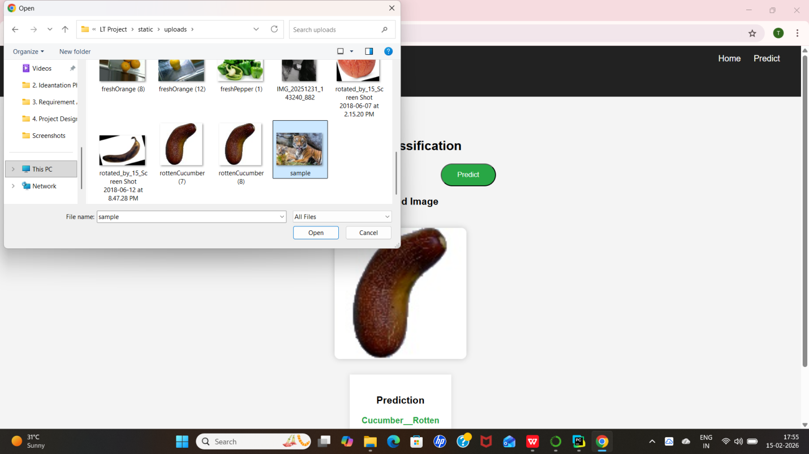

OUTPUT:
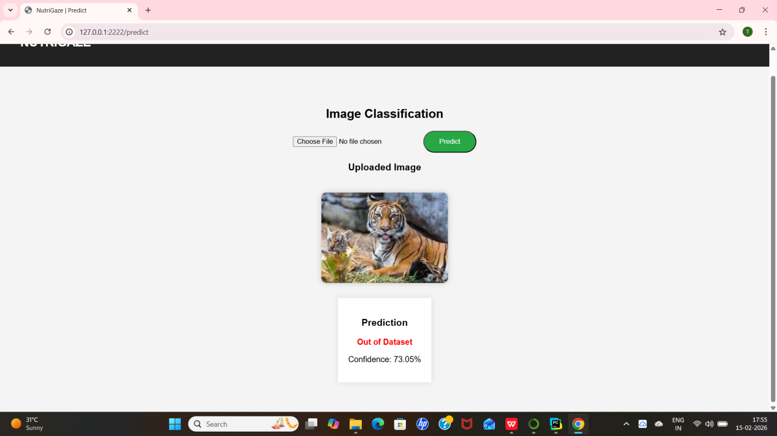
TESTING WITH HUMAN IMAGES:
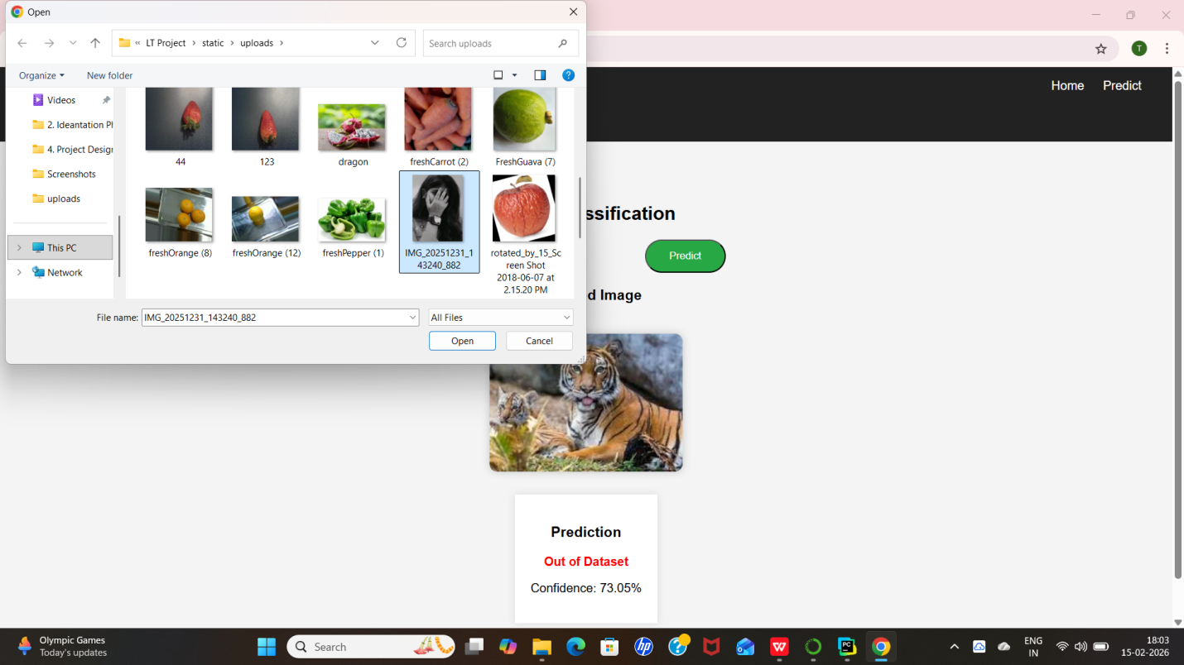

OUTPUT:


